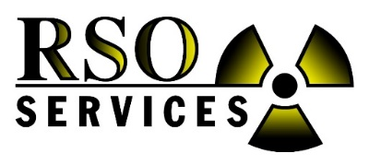

Radiation Safety Officer School

Fort Walton Beach, FL – August 2024
on the beautiful white sandy beaches of the Gulf of Mexico

40 Hour and Refresher RSO Course

Provided by: RSO SERVICES, Inc.

When: August 19th – 23rd, 2024 (check-in Sunday night)

- The Refresher course is for those who have previously obtained a 40-hour certification and only require a Refresher to maintain certification.
- Class begins promptly at 8:00am each day. Lunch is not provided.
- Includes an RSO training manual, notepad, and pen.

Instructor: John Hensley

Cost: $1,850.00 per student for the 40-hour certificate
$1,040.00 per student for the Refresher certificate

Location: The Island Resort at Fort Walton Beach (NEW LOCATION!)

1500 Miracle Strip Parkway SE, Fort Walton Beach, FL 32548
Phone: (850) 337-9194 (use Group Code: RSO Services August)
Hotel Link: The Island Hotel Reservation Link for August, 2024 (click here) code: 2408RSOSER
Call (850) 337-9194 to make reservations and ask for group code: 2408RSOSER. Limited RSO Services group rate rooms are available ($189.00 plus tax). Beach view suites are available at a higher rate. Students typically Check-in Sunday and check-out Friday. Room cancellation charges may apply. The hotel has waived the daily resort and parking fees for all students. The local airport code is VPS. Please call Holly at 205-924-1891 for any questions about the training class.

Course Description:
This class will introduce you to the regulations and safety aspects of handling fixed nuclear devices. It will help you design your own safety program and answer many safety questions that plant employees have. You will learn basic radiation theory, how to monitor and measure radiation, D.O.T. requirements, operating and emergency procedures, health effects, how to apply or renew licenses, State and NRC regulations and more. This course is approved by the State of Alabama Department of Public Health, State of Georgia, Mississippi, Florida, Tennessee, South Carolina, North Carolina, Louisiana and other state agencies throughout the country. Many states highly recommend our class for the industrial experience and knowledge we provide. Contact us if you need the class itinerary to submit to your state.

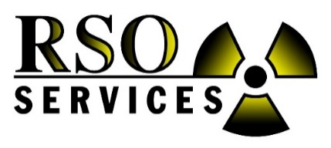
Radiation Safety Officer School
August 19th – 23rd, 2024 (Mon. – Fri.)

Fort Walton Beach, FL – August 2024
on the beautiful white sandy beaches of the Gulf of Mexico

The Island Resort at Fort Walton Beach (NEW LOCATION!)

1500 Miracle Strip Parkway SE, Fort Walton Beach, FL 32548
Phone: (850) 337-9194 (use Group Code: RSO Services August)
Hotel Link: The Island Hotel Reservation Link for August, 2024 (click here) code: 2408RSOSER
Three Easy Ways to Register:
1. Mail this form 2. Fax: 866-254-3211 3. Email: holly@rsoservices.com and cc: info@rsoservices.com
Billing Address: RSO Services, Inc., Attn: Accounts Payable, PO Box 575, Niceville, FL 32588
RSO Services Support: School questions, call Holly 205-924-1891. Billing questions, call Gail 850-651-0777.
*** PLEASE SEND THIS FORM AS SOON AS POSSIBLE FOR ATTENDANCE COUNT PURPOSES AND TO RESERVE A SPOT (LIMITED).

Company Name: ________________________________ Contact Name: ______________________________

Company Address: ____________________________________________________________________________

Phone: __________________________________ Cell Phone: ______________________________________

Fax: ____________________________________ Email: __________________________________________

Please indicate names of personnel, email and the courses they will attend (use letter W for Online Webinar option).
Courses: Choose either 40 Hour RSO Course ($1,850) or RSO Refresher Course ($1,040)

Name __________________________ Email _______________________________ _____40 Hr _____Refresher
Name __________________________ Email _______________________________ _____40 Hr _____Refresher

Name __________________________ Email _______________________________ _____40 Hr _____Refresher

Name __________________________ Email _______________________________ _____40 Hr _____Refresher

Course includes a complete training book and RSO Certificate per student upon completion.
Please make checks payable to: RSO Services, Inc.
Company purchase order or credit card (Visa, MC, AMEX) must be received 3 weeks before class begins to reserve your spot and ensure adequate training materials are available. A 3% fee will be added to credit card transactions. Cancellation charges of $500.00 per student will apply if not cancelled in writing 2 weeks prior to the class. Payment required before attending school. School may be cancelled due to Covid or low attendance.
Billing Address: RSO Services, Inc., Attn: Accounts Payable, P.O. Box 575, Niceville, FL 32588

Check is enclosed for $ _________________ P. O. Number _______________________

Credit Card Number ______________________________ Type _______________ (VISA, MC, AMEX)

Expiration Date _________________ Security Code (back of card) _______________

Print Name (on card) __________________________ Sign Name _____________________________
Billing Address_________________________________________________________________________
NOTICE: Student is responsible for booking & paying for their hotel room, transportation & food.
Remember GROUP CODE: 2408RSOSER when booking. Thank you for registering.

