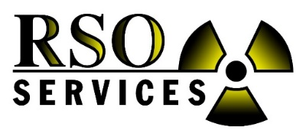

Radiation Safety Officer School

Pigeon Forge, TN – March 2022
in the magnificent Smoky Mountains

40 Hour and Refresher RSO Course

Offered by: RSO SERVICES, Inc.

When: March 7th – 11th, 2022 (check-in Sunday night)

- The 40-hour course is March 7th – 11th, 2022 (Mon. – Fri.).
- The Refresher course is for those who have taken the 40-hour course before and would like to pick and choose which parts to retake again. (2-day minimum)
- Class time is 8:00 AM to 4:30 PM each day. Lunch is on your own.

Instructor: John Hensley

Cost: $1,650.00 per student for the 40-hour course
$995.00 per student for the refresher course

Location: Holiday Inn & Suites Convention Center

2905 Parkway, Pigeon Forge, TN 37862
Phone: (865) 428-2525 (use Group Code: RSO Services)
Hotel Link https://www.ihg.com/holidayinn/hotels/us/en/pigeon-forge/pgftl/hoteldetail
Call (865) 428-2525 to make reservations and ask for group code: RSO Services
Limited RSO Services room rates are $129.00 plus tax. Check-in Sunday and check-out Friday. Check the hotel guest room cancelation policy to avoid charges. Call RSO Services for any questions 850-651-0777.

Course Description:
This class will introduce you to the regulations and safety aspects of handling fixed nuclear devices. It will help you design your own safety program and answer many safety questions that plant employees have. You will learn basic radiation theory, how to monitor and measure radiation, D.O.T. requirements, radiation procedures, both operating and emergency procedures, health effects, how to apply or renew licenses, State and NRC regulations and all that is needed to run a correct safety program at your facility. This course is approved and certified by the State of Alabama Department of Public Health, State of Georgia, Mississippi, Florida, Tennessee, South Carolina, North Carolina, Louisiana Nuclear Regulatory Commission and other state agencies throughout the country. Many states will not certify any 40 hr RSO course, but will approve or deny a class when submitted by the student. We have never had our 40-hour RSO class denied. Instead, many states recommend our class for the Industrial experience we provide.
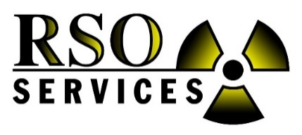
Radiation Safety Officer School
March 7th – 11th, 2022 (Mon. – Fri.)

Pigeon Forge, TN – March 2022
in the magnificent Smoky Mountains

Holiday Inn & Suites Convention Center

2905 Parkway, Pigeon Forge, TN 37862
Phone: (865) 428-2525 (Group Code: RSO Services)

Four Easy Ways to Register:
1. Register online (pending). 2. Mail this form 3. Fax: 866-254-3211 4. Email: info@rsoservices.com
Billing Address: RSO Services, Inc., Attn: Accounts Payable, PO Box 575, Niceville, FL 32588

*** PLEASE FAX A PO NUMBER OR CREDIT CARD TO RSO SERVICES AS SOON AS POSSIBLE FOR ATTENDANCE COUNT PURPOSES AND TO RESERVE A SPOT (LIMITED)*** We need to know this to ensure enough books are available.

Company Name: ________________________________ Contact Name: ______________________________

Company Address: ____________________________________________________________________________

Phone: __________________________________ Cell Phone: ______________________________________

Fax: ____________________________________ Email: __________________________________________

Please indicate names of personnel, email (needed to send certificate) and the course they will need for those attending.

Courses: Choose either 40 Hour RSO Course ($1,650) or RSO Refresher Course ($995)

Name __________________________ Email _______________________________ _____40 Hr _____Refresher
Name __________________________ Email _______________________________ _____40 Hr _____Refresher

Name __________________________ Email _______________________________ _____40 Hr _____Refresher

Name __________________________ Email _______________________________ _____40 Hr _____Refresher

Course includes a complete training book and RSO Certificate per student upon completion.
Please make checks payable to: RSO Services, Inc.
Company purchase order or credit card (Visa, MC, AMEX) must be received 3 weeks before class begins to reserve your spot and ensure adequate training materials are available. A 3% fee will be added to credit card transactions. Cancellation charges of $500.00 per student will apply if not cancelled in writing 2 weeks prior to the class. Payment required before attending school. School may be cancelled due to Covid or low attendance.
Billing Address: RSO Services, Inc., Attn: Accounts Payable, P.O. Box 575, Niceville, FL 32588

Check is enclosed for $ _________________ P. O. Number _______________________

Credit Card Number ______________________________ Type _______________ (VISA, MC, AMEX)

Expiration Date _________________ Security Code (back of card) _______________

Print Name (on card) __________________________ Sign Name _____________________________
Billing Address_________________________________________________________________________
NOTICE: Student is responsible for booking and paying for their hotel room, transportation & food.
Remember to provide GROUP CODE: RSO Services when booking the hotel room. Thank you for registering.

